**TITLE OF PAPER** 

(Times New Roman, 14 pt., bold, center, all caps)

**Author(s) Name**  
Scientific title, Institution  
E-mail: [author@email.com]  
ORCID: [0000-000X-XXXX-XXXX]

***Abstract:*** *The abstract must provide sufficient information to allow readers to understand the scope, methodology, main findings, and conclusions of the research. It should not be an introduction but a synthesis of key research insights. Avoid listing topics covered; instead, summarize major results and implications. The abstract should be written in Times New Roman, 10 pt., italic, single-spaced, and contain 200-250 words.*

***Keywords:*** *select 4 – 7 key terms (words or phrases) that reveal the essence of the paper. List these terms in the decreasing order of their significance.*

***Classification******JEL:***

## 1. Introduction

The introduction establishes the research context by referencing relevant literature and summarizing the current state of knowledge on the topic. Clearly define the research problem, objectives, and hypotheses/questions being addressed. Provide a concise overview of the methodological approach and outline the significance of the study. Whenever possible, briefly mention key results.

## 2. Literature Review

A critical analysis of existing literature, identifying gaps and positioning the current study within the academic discourse. Discuss theoretical frameworks, prior empirical studies, and relevant methodologies from past research. Ensure proper citation following the journal’s referencing style.

## 3. Methodology

This section should comprehensively describe the research design, data collection procedures, and analytical techniques. Ensure that methodological choices are justified, allowing for reproducibility. When applicable, include descriptions of datasets, statistical models, software used, and any experimental protocols. The section should be structured clearly and precisely.

## 4. Results and Discussion

Present research findings using structured text, tables, figures, and charts where necessary. Ensure clarity in presenting numerical results, avoiding redundancy. Provide detailed analysis and interpretation of results, comparing them to findings from the literature. Discuss implications, limitations, and potential future research directions.

Figures and tables must be numbered and labeled accordingly:

Graphs, charts and pictures should be inserted with the option Wrap Text – In Line with Text. Titles of that objects are written below them preceded by the number of the figure (Figure 1, Figure 2, etc.). A source should be added below the title of the figure.

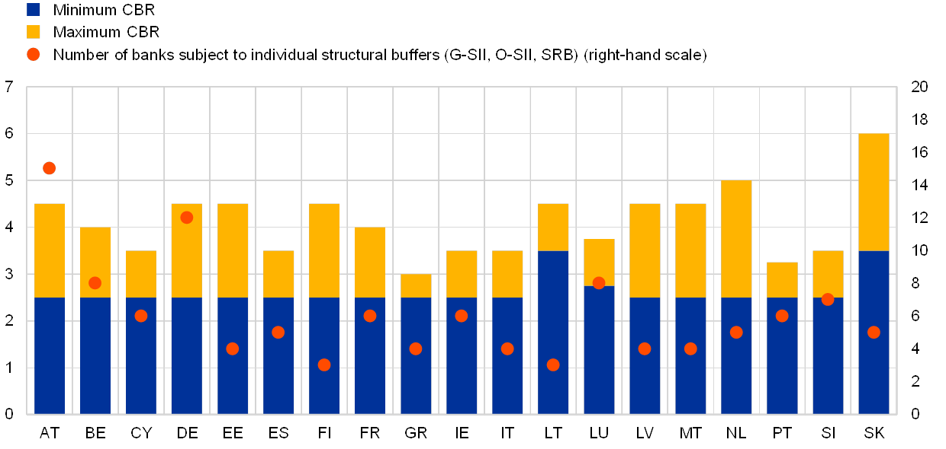

**Figure 1. Title of the figure (Times New Roman, 12 pt., bold, center)**

*Source: www.nsi.bg (Times New Roman, 10 pt., italic, center)*

Diagrams have to be clearly executed in order to provide visible black and white copies.

Tables should be numbered sequentially (Table 1, Table 2, etc.) and should have a title. A source should be added below the table.

**Table 1. Title of the table (Times New Roman, 12 pt., bold, center)**

|  |  |  |  |  |  |
| --- | --- | --- | --- | --- | --- |
|  | **2002** | **2007** | **2012** | **2017** | **Population for 2018, million** |
| Bulgaria | -85500 | -83742 | -24472 | -24001 | 7024216 |
| Czech Republic | 47402 | 250889 | 59997 | 59997 | 10625695 |
| Estonia | -18406 | -15151 | -10516 | -4999 | 1320884 |
| Hungary | 61589 | 25150 | 29999 | 29999 | 9768785 |

*Source: World Bank* [*http://www.worldbank.org*](http://www.worldbank.org) *(Times New Roman, 10 pt., italic, left)*

Data in the table should be formatted with Times New Roman font, 12 pt. A table should be centered against the text in the paragraph/subparagraph.

Number all equations and formulas placing their numbers in parentheses, on their right side.

Explain abbreviations and acronyms when they appear first in the text, even if they have been defined in the abstract.

Do not use footnotes, but endnotes are allowed, located before the bibliography. They shall be written with Times New Roman, font size 10, italic and shall be included in round parentheses.

## 5. Conclusions

Summarize the key findings of the study, highlighting their significance. Discuss theoretical and practical implications, and propose recommendations for future research or policy-making. Do not merely repeat the abstract. Instead, emphasize contributions and applications of the findings.

## 6. References

References should be formatted according to the **ISO 690:2012** standard, in numerical order based on citation sequence within the text. The reference list should include only sources that have been cited in the paper.

### Books

AUTHOR(s). *Title: subtitle.* Edition. Place: Publisher, Year. ISBN.

*Example:*  
SPIRIDONOV, V. P., LOPATKIN, A. *Mathematical Treatment of Physical-Chemical Data.* 2nd ed. Moscow: MIR, 1983. ISBN 84-401-0970-9.

### Journal Articles

AUTHOR(s). *Article title.* Journal title, Year, Volume(Number), Pages. ISSN.

*Example:*  
CARRASCO, C. *La paradoja del cuidado: necesario pero invisible.* Revista de Economía Crítica, 2006, (5), 39-64. ISSN 1696-0866.

### Conference Papers

AUTHOR(s). *Chapter title.* In: AUTHOR(s) or EDITOR(s). *Title of book: subtitle.* Edition. Place: Publisher, Year, Pages.

*Example:*  
LÓPEZ-AGUILERA, E., HEUSSE, M., ROUSSEAU, F. *Performance of wireless LAN access methods in multicell environments.* In: *Proceedings of the Global Telecommunications Conference, 2006: GLOBECOM'06.* New York: IEEE, 2006, pp. 1-6.

### Electronic Sources

#### Websites

WEBSITE NAME. *Title of page/document [online].* Year (if available). [viewed Date]. Available from:   
*Example:*  
WIKIPEDIA. *Economic resilience [online].* 2025. [viewed 12 February 2025]. Available from: https://en.wikipedia.org/wiki/Economic_resilience

#### Reports and Institutional Documents

INSTITUTION/ORGANIZATION. *Title of report/document [online].* Place: Publisher, Year. [viewed Date]. Available from:

*Example:*  
WORLD BANK. *Global Economic Prospects [online].* Washington, DC: World Bank, 2024. [viewed 10 January 2025]. Available from: https://www.worldbank.org/gep2024

#### Legal Documents (Laws, Government Decisions, etc.)

COUNTRY/INSTITUTION. *Title of the law/decision.* Number, Date. Official publication source. [viewed Date]. Available from:

*Example:*  
GOVERNMENT OF ROMANIA. *Law No. 31/1990 on Companies.* Official Gazette No. 126/1990. [viewed 15 March 2025]. Available from: https://legislatie.just.ro/Public/DetaliiDocument/123456

## Formatting Guidelines

* **Font:** Times New Roman, 12 pt. (text), 14 pt. (title, subtitle), 10 pt. (abstract, tables, and references)
* **Spacing:** Single line spacing
* **Alignment:** Justified
* **Equations:** Numbered and aligned to the right
* **Figures & Tables:** Numbered sequentially, centered, and referenced in the text
* **Endnotes (if necessary):** Placed before the bibliography, Times New Roman, 10 pt., italic